Marketing 441

Sustainability Marketing Plan

Brittany Brock, Wes Davic, Grant Panko, Mitch Obenrader

**Table of Contents**

Executive Summary 2

Market Analysis 3

Introduction 4-5

* Background
* Target Market

The Four P’s of the Marketing Mix 6-11

* Product Description
* Distribution Plan
* Pricing
* Promotional Plan

The Impact on Sustainability11

References and Sources 12

Appendix 13

Team Participation 14

**Executive Summary**

Oral care is a very large industry and at a constant growth, a big portion of that industry in toothpaste. So we put our focus on that, and came up with a much more environmentally friendly and sustainable container for toothpaste. The container will be in the shape of a cylinder and will have many benefits such as:

* Little to no toothpaste wasted
* Post-consumer material
* Easily recycled
* Promote environmental efforts
* Potentially save money

This product could be one of the first in the industry, several brands have considered it and are aware that it could be beneficial. We hope that it will not only appeal to customers that are making efforts in protecting the environment but to people who are looking for a toothpaste that they can get their money's worth and not have to throw away a tube a toothpaste that still has some left in it. Studies show that up to 13% of toothpaste is left in the tube and will be thrown away because it can’t be extracted. We want to focus most of our advertising and promotion through the world wide web, with online stores and advertising. If the product is a hit and there is a larger demand then we will expand to supercenters and possible smaller stores. We have great plans on how to utilize shipping to help expand and have used a couple of marketing research techniques such as a survey to obtain some information about the traditional toothpaste container.

**Market Analysis**

Toothpaste is the largest product segment of oral care, about 74%, in the United States. It is used frequently on a daily basis among all age groups, demographics, and social class. The primary functions of the product are tooth cleaning and tooth decay prevention. On average, households use between one and two tubes of toothpaste a month. 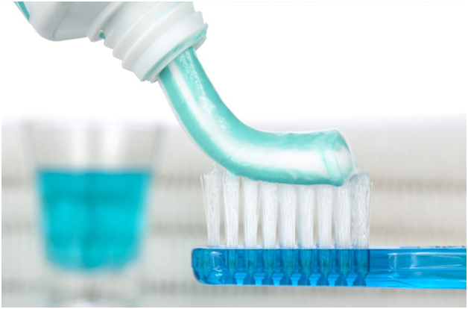

The industry growth is slow and fairly constant, with a few percentage points a year, roughly due to the increase in the population and teeth. The main competition in the industry is Colgate-Palmolive, Procter & Gamble, and Unilever. The rivalry among existing firms is on a medium range. The firms compete against each other but often face issues with consumers being set in their product consumption behaviors. Therefore, companies strive in perfecting their product formula, increasing marketable selling points, and utilizing attractive packaging. In addition, this makes the threat of new entrants to be low since there are already a plethora of name brand established companies. Bargaining power of suppliers is an increasing issue. Toothpaste manufacturers have been subject to rising production costs over the past five years, as raw material prices and labor costs increased. Some smaller companies were forced to exit the industry, while others were acquired by larger ones. One way to reduce these costs is to introduce a more sustainable packaging and product container.

Currently, there are already some well established sustainable brands in the industry including Tom’s of Maine, Kiss My Face, and Desert Essence. Most of these companies utilize natural or organic ingredients and some have even started using better materials for their packaging. Tom’s of Maine stated that they are always looking for opportunities to reduce their environmental impact. “It's not good enough to just make natural products. They also have to be packaged with consideration for the environment and ease of use.” - Fiona Russell, Tom’s of Maine Personal Care Brand Manager. According to their website, their toothpaste cartons are made of post-consumer recycled paperboard and the company used vegetable based inks on materials and packaging.

**Introduction**

Our product is a cylindrical tube of toothpaste, similar to a peanut butter jar that utilizes every ounce of product in the container. Currently in every model of tooth paste, it features a squeezable pouch with a little mouth. Once the paste is squeezed out it can’t be put back in due to the small opening. This results in overuse and higher toiletry cost for the customer over a year. Our focus is on substantially reducing the material usage of toothpaste containers, along with saving the customer a significant amount of money throughout the years to come.

This started from the problem that no one likes to spend their money on basic needs such as toothpaste, eye contact solution, toilet paper, but they have to because they are necessities. Since all of us are in college, and currently on a strict budget, we could relate very easily to this dilemma. We thought of a way to make full use of an otherwise wasted product. The average user doesn’t usually fold over and try to squeeze out every last bit of paste when the tube’s life is coming to an end. Thus leaving behind perfectly good tooth paste and causing the consumer to waste money on product that isn’t used simply because the container is very inefficient. We devised a new way to transport and reduce the amount of material needed to deliver tooth paste product to consumers all over the world.

We are targeting anyone who wants clean teeth. Tooth paste really has no demographic or age limit. This gives our company the ability to market to everyone. Granted some people have more sensitive teeth than other, which gives us the option to release more than one type of paste. This would be considered a long term strategy once we saw success on our current product. The reason our current product would succeed so well is because we could deliver more toothpaste at a lower cost to the consumer which would last them a longer time. How is that possible? By getting rid of the standard pouch paste that we have all grown accustomed too, we increase our volume of paste in each individual tube simply because of the shape of the container. In a pouch, the mouth of it is fat and narrow, but it slowly widens and tapers out on the end. Our container is a sleek looking cylindrical tube that holds more and costs less. It costs less because we can transport much more in one truck than the standard cardboard box package that all toothpaste containers come in. By maximizing our shipping standards, we not only deliver more product to a store on one truck, we reduce the carbon footprint of our company on a day to day basis with less trucks on the road. Through this method we would drive a lower price because of the lower overhead needed to maintain our fleet. It is quite amazing to see the snowball effect on a company simply because of the shape of its container.

Through the basic survey we took around campus, most students we asked, don’t roll up and fully utilize all the product in the tube. We went further and asked parents of smaller children that brush their own teeth. Their main complaint was that they waste too much tooth paste on each use, which costs them more money than necessary. Every parent said that they were interested in saving money on toiletries every year if they could. By calculating 4 tooth paste tubes used per year by one conservative person, if a family of 5 were to switch to our product it would save them roughly $40 a year on toiletries. That may sound insignificant but if someone walked up to you and offered you $40 dollars, would you take it? Money that can be used for gas, groceries, or even pizza night. This is what the concept of product is based around. Keep the same quality, but get more out of it.

**The Four P’s of the Marketing Mix**

**Product Description**

To improve and enhance the environmental impact on a toothpaste product, we have decided to introduce a new form of toothpaste container with minimal packaging. It will utilize components similar to the toothpaste from Tom’s of Maine, where there will be vegetable based inks and post-consumer materials for the packaging. The basic description of the container is a flexible material (plastic or rubber) in a cylinder shape. The container will be able to be squeezed for consumer usage at the beginning of the product life cycle. Towards the end of the life cycle when the tube can no longer be squeezed to get the remaining toothpaste out, the container can be opened. The curved smooth sides and the ability for the toothpaste container to be opened gives the consumer ample opportunities to scrape out the remaining paste and utilize the product to it’s full advantage. Also, the cylinder shape reduces the excess of unused toothpaste that normally gets trapped in the corners of traditional tubes. The container will be free-standing on market shelves and only require a recycled plastic safety seal to ensure customer protection. 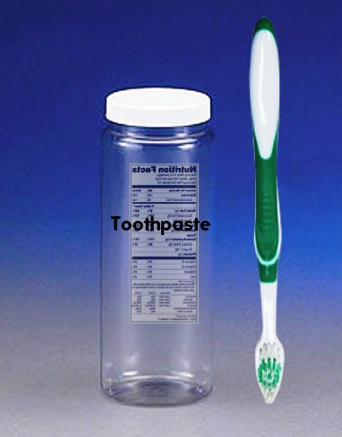

**Distribution Plan**

When our product first hits the market, we are going to use an online approach. The online approach allows us to get orders from all over at once. This will make us form distribution channels across the country. Having an online approach to our distribution allows us to find easy routes to ship our product through, while getting instant feedback on our product. Online distribution allows for a broad market to be reached by our sustainable product. The online approach allows for no intermediaries to be used and revenue to be made when a payment goes through for the product.

We will add in a wholesale distribution plan later in our product life. Wholesaling allows for us to sell our products and have them distributed in a large area. Wholesaling allows for large amounts of our toothpaste to be sold and us to get the revenue without having to worry about getting the product sold to retailers. This approach will allow for us to focus our efforts towards making the most sustainable product on the market, while keeping the price at a minimum, which draws more customers to our product.

With either form of distribution, being sustainable is something that needs to be achieved. When shipping our product, it takes up little space in packaging, so we can ship a large amount, in less space than our competitors. This creates the use of less fuels for the vehicles to ship the product. Having a more efficient and sustainable supply line allows for less money and time to be spent on distributing our product, opening up a chance to focus more on the product than the distribution.

**Pricing**

Our pricing is very simple. We want to have a lower unit cost than anyone else in the market, but we want to offer the largest volume container. By doing so our customers will purchase for convenience and for going green. We will have low prices because of the way we designed our product. We don't have a packaging plant. We don’t have graphic design artists or machines that produce ink printed cardboard. The shape of our product allows for more to be shipped than if it were square, which would save money of fleet repairs and upgrades. Our customers will stand behind the idea of 100% recycled plastic bottles and packageless products. It’s new, innovating, and exciting. Our product paste is green and blue and will stick out right on the shelf unlike all the other products

**Promotional Plan**

**Goal:** The main objective of this product is to take the sustainability of toothpaste to a new level. There are brands out there that have made efforts towards being environmentally friendly, but with their ingredients. Tom’s of Maine is on the right track and has said that the ingredients of the product is not enough, and that the packaging is a must in trying to make this product “Green”. So with our toothpaste we have decided to take the environmentally friendly ingredients and combine it with a friendlier packaging. We described what our product is earlier in the Marketing plan and we hope that this product will enter the market as one of the first fully sustainable toothpaste. Go into any store and you’ll see Crest and Colgate pushing the mint flavor with refresh chips in them. It gives the tooth paste a better aesthetic look and kicks up the mint. Most places don’t sell a much demanded cinnamon flavor. By going into other realms other than mint, we can effectively add that factor to our competitive advantage. We would offer the standard flavor of mint, but we would also complement it by adding cinnamon, much like a big red taste, and for kids’ grape or strawberry. Let’s face it, brushing our teeth is boring. If you can change up your normal ritual by adding a different or new flavor, it would make it something fun to do in preparation for the day ahead. Of course these flavors would be factory and market tested before a full scale supply is produced. Our cylinder would be a clear tube, but our paste would be an electric blue and green with swirls in it. The shape itself draws you in for a closer look, but the colors of paste would make you want to buy it and try it. It’s that simple, no matter how colorful a competitor’s package gets, nothing can beat the real thing. Also this reduces the demand for ink. We would have to buy thousands of gallons of ink a year to print blue and green pictures on a piece of cardboard that just gets thrown away. We simply let the product itself do all the talking.

**Target/Message/Theme:** The product is designed to be environmentally friendly so the color green will be the main outstanding color on the packaging and container label and possibly the toothpaste itself. In order to stop the destruction of our world and help maintain it, the little things matter. Reducing the amount of toothpaste that is wasted and creating a more sustainable container is a small step in the environmental efforts but will be added to all the other small steps being made that create one big effort. This being our message will give the customers the thought and satisfaction that even though it's just toothpaste it will make a difference. With that being said we plan to target all ages and all backgrounds. The toothpaste will be designed to appeal to people looking at making an effort in helping the environment. But there is one aspect of our product that will appeal to customers that have no interest in the environment. That is the fact that you will be able to get every last ounce of toothpaste out of the container. So that means no toothpaste will be left inside the container so it gives customers the satisfaction that they get their money's worth.

**Promotion/Distribution:** Since our target is essentially everyone, promotion will have no specific advertising, the advertising will be mainly through the web and online sources, and promote the product as sustainable and a step towards helping the environment. Things such as apps, websites, and of course social media will be the main sources of advertising. With the apps our product would be appear on multiple apps that people often use and will also provide easy access to our online store by simply pressing on the advertisement. The same thing will apply for websites. With social media we will create our own accounts and promote it that way. Also we will find accounts on social media that are apart of sustainability/environmental efforts and will use them as a form of advertising to post our product. On the other side of advertising we plan to throw in a little public advertising, with some posters on bulletin boards in high traffic public areas. Another thing we plan to do is to have some tables set up in public areas to offer small samples, brochures, and to have people sign up to help promote our product on social media and in return they will receive two free tubes of toothpaste. They will also give us feedback after they have used the product and that will help us obtain data about our product.

**The Impact on Sustainability**

Being sustainable as a company is a very important aspect. With the emphasis on the environment being so big, companies need to create ways to make sustainable choices. This new sustainable toothpaste container is very sustainable product. The container is made of recycled plastic, eliminating the use of new raw materials to be used for containers. The safety seal that is attached would be the only piece packaging placed on the product. This creates a more environmentally friendly product as less waste is produced.

The cylinder shaped tube will be allow for more tubes to be shipped at once, minimizing the carbon footprint made in the distribution effort. The toothpaste will not have the unnecessary cardboard box as a packaging. Without the cardboard packaging, thousands of gallons of ink will be saved per year. Shipping the product without the rectangular cardboard boxes that get thrown away, will save millions of pounds of paper per year as well. Offering sustainable products will enhance the public’s view on the company, increasing the sales of our sustainable products.

**References & Sources**

"All About/Toothpaste; Growth Is Glacial, but the Market Is Big, and So Is the Gross." *The New York Times*. Ed. Anthony Ramirez. N.p., 13 May 1990. Web. 18 Apr. 2016.

"Colgate-Palmolive Is a Leading Fast-Moving Consumer Goods Firm ." *Market Realist*. Ed. Penny Morgan. N.p., 27 July 2015. Web. 19 Apr. 2016.

“Distribution Methods and Marketing Plans." *Small Business*. Chron, n.d. Markgraf, Bert. Web. 25 Apr. 2016.

"Toothpaste and Toothbrush Manufacturing in China." N.p., Mar. 2016. *IBISWorld*. Web. 21 Apr. 2016.

“Shake, rattle, and squeeze: How much is left in that container?” Consumer Reports Magazine. September 2009.

**Appendix**

Product Design

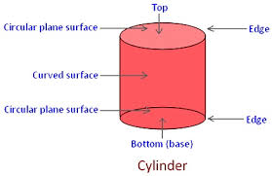

**TEAM MEMBERS’ STATEMENT OF PARTICIPATION**

Product/Project Name: Sustainable Toothpaste Container

*By signing the statement below, we attest that the information is correct.*

Team Member 1 Name: _Brittany Brock__________ (print) _______________________ (signature)

Contributions: Wrote the market analysis, product description part of the four p’s of marketing, and created the basic product design picture.

Team Member 2 Name: Grant Panko (print) _______________________ (signature)

Contributions: Wrote the distribution plan and impact on sustainability that the new product would have.

Team Member 3 Name: Wes Davic (print) _______________________ (signature)

Contributions: Wrote the introduction of the product and the pricing section.

Team Member 4 Name: Mitch Obenrader (print) _______________________ (signature)

Contributions: Wrote the executive summary and developed the promotional idea for the product.