The Irrational Innovators

Joseph Neff and Grant Panko

Erie Times News Marketing Research Project

December 14, 2015

***Table of Contents***

Executive summary 2

Introduction 3

Background Story 4

Methodology 6

Analysis 7

Results 8

Conclusions 8

Limitations 9

References 10

Appendix 11

***Executive Summary***

The issue that we are addressing in this project pertains to millennials and how they receive news. Millennials are labeled as the age group between the birth years of 1980- 2000’s. This generation is seen to be more technological than any other group and make up over 25% of America today. Millennials grew up in an electronic-filled and socially-networked world. They are the generation that has received the most marketing attention and are the most ethnically diverse of any generation. Erie Times News has asked us to conduct market research in an attempt to understand the millennial demographic as well as form a strategic plan to market Showcase to them. In order to find the answers to these questions we conducted focus groups and online questionnaires to figure out why and how millennials read and share news. The focus groups and questionnaire were very broad but all shared the same general idea, “how do you obtain news”. In the focus group we asked the participants specific yet general media questions that helped us understand what being social means to them as well as how it pertains to others. We then followed up with questions asking how they believe they are socially active within their environment, the answers allowed us to understand the daily social activities of the millennial lifestyle as well as help put it in perspective to other generations. Our next question asked how the participants pertain and acknowledge information weather through news or by word of mouth. During this procedure we discovered that the millennial generation is one that relies heavily on friends and family to obtain information. Most participants in the study said that they would not go to a social event if they weren’t going with another person, they always wanted to be assured of an extra support before deciding to go somewhere. The final question, which was our most important discovery that I feel is relevant to Erie Times News, was asking which format they preferred more, print or mobile. The answers that we found were astonishing and led us to a conclusion that we have talked about before but until further evidence existed we could not continue on with. The information we obtained showed us that millennials were mobile people, the millennial generation does not read print because they feel it is inefficient and inconvenient. “Why go outside and walk to your mailbox every morning when you can wake up and pull the information up on your phone without even leaving your bed” one argued. This comment spoke wonders to our group and helped us create a conclusion as to how to help the Erie Times with their showcase problem as well as help relate it to the millennial generation and hopefully other generations to come. By learning that Millennials don’t read print as well as knowledge that they share information rapidly through friends and family, we have decided to suggest that Erie Times create a Showcase application which can be accessed through mobile and the internet. These strategic implications will cost a lot of money as well as need time to get established but we believe that in the long run, this is the Erie Times News best option to reach out to the younger demographic and bring in more viewers for the future.

***Introduction***

The main idea of this report addresses the marketing aspect of the millennial generation and how we as marketing researchers can find outlets of interest to help companies relate their products to the younger demographic. Our class have been specifically asked by the Erie Times News to conduct research on how millennials receive and distribute news. The idea of this project came from the consumer marketing manager Amanda Farrell, during her presentation she explained that the main questions that needed to be asked were what channels needed to engaged for higher marketability, how the customization of news and information will be beneficial to our cause and how do people consume news in general. She went on to explain that this project was not for the general business of the paper, but for a specific branch called Showcase.The main purpose of Showcase is to inform people from the Erie area about the upcoming week’s social events and activities. It is around 30 pages, and its main source of revenue comes from advertisements. There is also a job section in the magazine. The market that is being targeted toward Showcase now is mainly people with an active lifestyle. The average age of the subscribers is 50 years or older and the last time Showcase was revised with its format was five years ago. Our goal was to find out why Showcase was not being read on the large scale of the normal sunday paper as well as figure out, through research, how we can more adequately market Showcase to the younger demographic. By doing so we had to ask ourselves a specific question, is Erie Times still relevant to the community that they are targeting and, if any, what changes should they need to make to stay relevant? Off of this assumption we have formulated our questions and designed our research around the criteria of millennial targeting.

We have created a variety of research methods that will test the true liability of our results in order to create the most accurate research design for this project. Through focus group and online questionnaires we will find out if the age of the viewer is positively correlated with the amount of readership being experienced. Although through this method we expect to learn a lot about the millennial generation and how they have adapted new ways to view material, we also know that within our online questionnaires we must use statistical analysis and regression in order to find the correct correlation. This means we must understand and interpret specific information as well as disregard any outliers we see that will askew our information.

Our group believes that once all the information is gathered and a statistical analysis is made, the findings will show that the reason why Showcase is not receiving millennial attention is due mainly to the fact that it is still in print form. We hypothesize that because the world has become a mobile networking powerhouse, the millennial generation does not read print and won't in the near future. This idea is mainly due to the idea that we are millennials ourselves and we feel that if an informational source created in print it is less likely to be read because we are more keen to receiving information through the media and internet.

***Background Story***

Millennials are labeled as the age group between the birth years of 1980- 2000’s. Although there may be some people who don’t fit the descriptions of a millennial, those who are born within this time period are still considered one, technologically inept or not. This generation is seen to be more technological than any other group and make up over 25% of America today. Millennials were born in an era where social network has become the main form of communication along with relying on the internet for everyday needs. They are the generation that has received the most marketing attention and are the most ethnically diverse of any generation. Millennials tend to be accepting of difference. Millennials are socially active, especially through the internet and are generally comfortable with the idea of a public Internet life. This comfort with social media means they are good at self-promotion and adopting connections through online media. From an article on the Financial Express, millennials “primarily go online for social or entertainment activities, and few follow current events” (Classifying Millennials). Millennials have different communication habits and are way more connected and in-tune with technology and online culture. Growing up with access to information at their fingertips, they have become accustomed to an on-demand lifestyle as well as allowing them to adapt to new programs and operating systems more quickly than other generations (Howe). Through research and analysis we can confirm that the millennial market is one that every business should strive to connect with due to the future marketability of the generation and their potential buying power within the economy.

Millennials are different in their consumption of news compared to the older generation. Millennials seem to be getting their news in more than just the traditional way of reading the newspaper or watching the news. They have started to switch to a digital format of getting their news on a daily basis. The change comes because of how millennials lives are. They are trying to get their news, while fitting how they get it into their daily activities. Now, although millennial readership does exist, it’s nowhere near as frequent as older generations when it comes to heavy reading. Yet, this is not to say that we have abandoned print news completely. “The New York Times maintains that one out of 10 of its print subscribers are between the ages of 18 and 24, and its website enjoys millions of millennial visitors each month. Perhaps then millennials have just shifted to the online offerings, not completely abandoning news overall” (Freier, 2015). Millennials are also still willing to pay for their news subscriptions. A recent article from The Guardian said that 40% of adults 18 to 34 pay for at least some of the news they read. This stat shows that a decent percentage of millennials want to be involved in the news on such a basis that they are willing to pay for what they want to read. Even with all the free sources of news out there, they still feel compelled to pay for news in some way to get more stories or different stories than the free sources offer. For millennials, we see a wide range of topics being consumed. With the ability of one click taking us to a story, we see that we can now pick and choose what we want to read about. Bleiberg and West said that on average, millennials follow about 10 different news topics. This includes 70 percent saying that their social media feeds have a good mix of topics to read about daily. This allows people to access more news, at a faster rate which allows them to be an information guru at their fingertips. Everyone wants to be informed about the world's most trending topics which is why news companies and social media websites must always have current news stories at the helm of their consumers.

Although we have access to articles that have described millennials and how companies have had to alter their marketing plans in order to create viewership, we believe that the information obtained through this project will be able to help companies worldwide develop marketing schemes to help reach out to the millennial demographic. We plan on using a broad set of principles within our research that our information can be used anywhere in the United States to help understand and comprehend the best way to market the the millennial generation.

***Methodology***

1. Our research design was broken up into two parts, focus group and an online questionnaire. The focus group was conducted with participants from campus, in order to receive credible and marketable information we had to make sure we surveyed people who were born in the millennial era as well as know personal background information so that they could give in incisive information about technology and how they use it during everyday life for social purposes. During the presentation we asked very generic questions in attempt to not give away the company which we were conducting research for.
2. The focus group questions consisted of bland criteria in order to understand social millennials and their entirety. What does being social mean to you? Can you give us some highlights about your social activities? Where do you get the information on social events? How do you hear/know what is going on in Erie? Which information sources do you find more reliable when it comes to getting your social events? What are the important factors that make you attend social events? Which format do you prefer (paper vs. mobile)? Why? What is your opinion on social media being a source for social events? These questions along with other verbal comments we recorded allowed us to formulate and develop our hypothesis as well as continue on with our research with a newly developed method for millennial readership. Our second method was through an online questionnaire which we sent to friends and family no matter the age to find out how large the Erie Times News viewership was as well as figure out how people receive their news on a regular scale. The questionnaire was set up to first distinguish the age and yearly income of the person being surveyed, afterwards specific questions were asked about personality and how they receive news and information in their everyday life. After the information was entered and analyzed we broke up the data into age and income to decide who, what and where Erie Times News is most relevant and how specific demographics receive and distribute daily news.
3. Our focus group was made up of millennials who attend college. Each one had their own background, which made our findings in our focus group the ability to give us a wide range of opinions. We had people who enjoyed the digital ways, as well as people who read the paper everyday still. Having this kind of diversity opened our eyes to what the majority of people were doing to gather news, as well as how they believed they would get the news in the future. For the survey, we had over 280 people take it, but due to significant outliers, some were eliminated, leaving us with 228 usable millennial respondents. The people in the survey had to be millennials, so they were between the ages of 18 and 39. They differed in level of education, as well as income, and where they lived. This sample variety gave information that was needed to decide what was the best thing to do for showcase.
4. The collection method used for the focus group was two student recorders from our group writing down what was being said as the other conducted the focus group. We also recorded the focus group on a phone to allow ourselves to go back and re-analyze our gathered information. The survey was built on a survey site. Each group member had to send it to ten individuals that are classified as a millennial.

***Analysis***

The main sampling method that our group used during this project was non probability sampling. Being bound by time, money and workforce and because of these limitations, as well as it being almost impossible to randomly sample the entire population. The core characteristic of non-probability sampling techniques is that samples are selected based on the subjective judgement of the researcher, rather than random selection, which is the cornerstone of probability sampling techniques. We used this idea to incorporate only people who live in Erie into our sample, while removing outliers that did not live in this area. After receiving the statistical information from the survey we also conducted descriptive statistics ,to test the normality of the data because we also ran a regression analysis and data has to be normally distributed. Regression analysis because correlation does not give you the direction of the relationship, it just tells you whether there is a relationship, also regression finds out the strongest predictor and what predicts our dependent variable the most.

***Questioning Method***

We conducted both a focus group and an online survey. During the focus group we did not mention anything about Erie Times News or Showcase, we did not want our participants to know the client's name in fear of subjectivity or bias answers. Instead we kept it general and told them that this study was done to understand how millenials obtain information about social events and what sources they use to get their information. We also used another one of the most widely utilized survey methods, an online survey. This is the systematic gathering of data from the target audience characterized by the invitation of the respondents and the completion of the questionnaire over the World Wide Web. Whether it is market or scientific research, the online survey is the fastest way of collecting data from the respondents as compared to other survey methods such as paper-and-pencil method or personal interviews. The online questionnaire method is beneficial in the ease of data gathering, minimal cost to conduct, automated data input and output, increased response rate and flexibility of design. Although there are also many downfalls to the online questionnaire method such as the absence of the interviewer, inability to reach a challenging population, and survey fraud.

***Results***

From the results of the research, it gave us an insight into the millennial lifestyle. The results showed us that print readership, while it may be dying, is still relevant and can be increased. If a company is more active in the online community, you will see more people reaching for the newspaper and reading more stories. We also saw that digital readership increased as the amount of social platforms the story or company was exposed on increased. This allows for a company to use free social media to get their information out to their audience at a minimal cost, along with creating a bigger reader base as others are exposed. With others being exposed to the information, we saw with our research that having a sense of community about the stories or events, makes one more likely to read about them and be engaged in the site.

***Conclusion***

After all of the data was reviewed, both the focus group and the survey information, our groups primary conclusion came down to the idea that millennials have to receive news in a social media format while also feeling a sense of social community. These results, driven from our statistical analysis, formed a ideal that in order for Showcase to be successful with the Millennial generation, they must be present and prominent on all social media platforms. We advise them to do this by recreating their media outlook and introducing new accounts on all their social disciplines. By doing this we believe that it will help reinvent the Erie Times News look among new and existing readers. By creating an Instagram account, consumers will be updated with the news through daily content with pictures and links to the articles.Readers can better navigate which stories they want to read, be more engaged with pictures, and create a more exciting atmosphere which creates sharing opportunities among friends and family with this new information method. This idea will also be present in their twitter which will be used as just the “showcase” material, this way readers are able to follow specific content without being bombarded by non relevant material they don't want to read. In conclusion we believe that if the Erie Times News does these specific tasks, they will change their outlook on social media to be more positive within a millennial mindset as well as drawn in potential consumers to buy the print version due to advertisements and constant new material that the consumer can read about.

***Limitations***

The downside of the non-probability sampling method is that an unknown proportion of the entire population was not sampled. This entails that the sample may or may not represent the entire population accurately. The survey method is also subject many downfalls such as the absence of the interviewer, inability to reach a challenging population, and survey fraud, which is why after we have concluded in the testing that we must discover outliers to ensure our information is correct and honest. there are also many downfalls to the online questionnaire method such as the absence of the interviewer, inability to reach a challenging population, and survey fraud. Having conducted both a focus group and online survey we were able to figure out what we believe to be the wants of people living in Erie and millennials but to backup our data, we would need to redo the survey multiple times to show our results to be correct without outliers. We also didn't have all the opportunities to conduct the research necessary due to time conflicts and the nature of the course being introductory to college students. If a professional marketing research team took a look at our information they would find some very interesting facts but this idea can be delved deeper into through time and other research methods to help provide a more in-depth viewpoint. After conducting our survey, we did not have the knowledge to interpret the information ourselves. We also struggled at times with the work load due to being a two person team. I believe having to conduct research and surveys with only two group members hindered our potential due to the idea that we had to write essays and create presentations without the help of more people.

***References***

Market Street Research. (n.d.). Retrieved October 19, 2015.

Market Street Research. (n.d.). Retrieved October 16, 2015.

McDaniel, C., & Gates, R. (n.d.). *Marketing research* (Tenth ed., pp. 92-116).

Bleiberg, J., & West, D. (2015, April 20). How Millennials Consume the News. Retrieved October 5, 2015.

Forty Percent of US Millennials Still pay for News. (2015, September 30). Retrieved October 5, 2015.

Millennials' nuanced paths to news and information. (2015, March 15). Retrieved October 5, 2015.

Editor & Publisher ®. (n.d.). Retrieved October 1, 2015.

Turns out traditional publishers do just fine with millennials - Digiday. (2014, August 26). Retrieved October 5, 2015.

Millennials: An Emerging Readership. (n.d.). Retrieved October 5, 2015.

Taibi, C. (n.d.). It's Going To Be Okay, Millennials Are Still Reading The News. Retrieved October 3, 2015.

***Appendix***

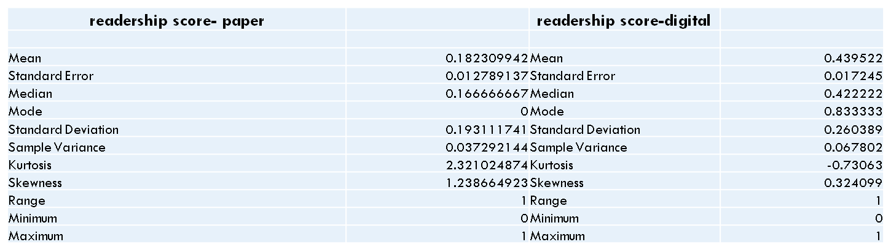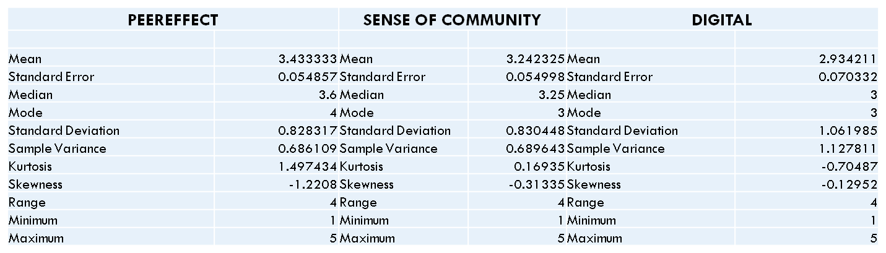

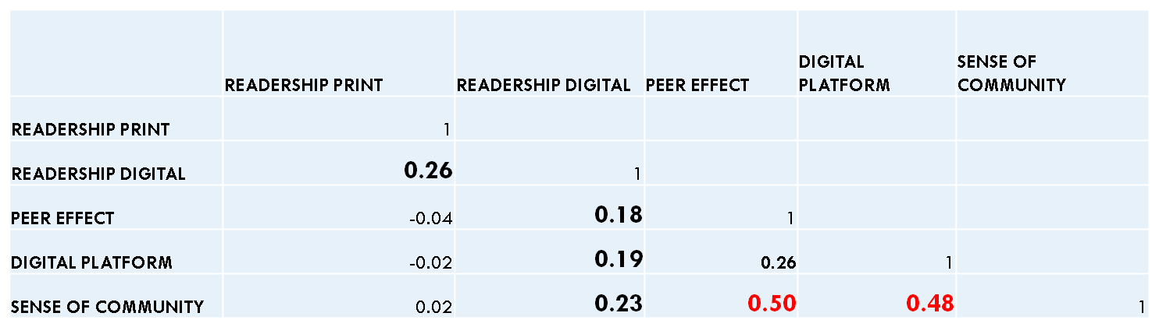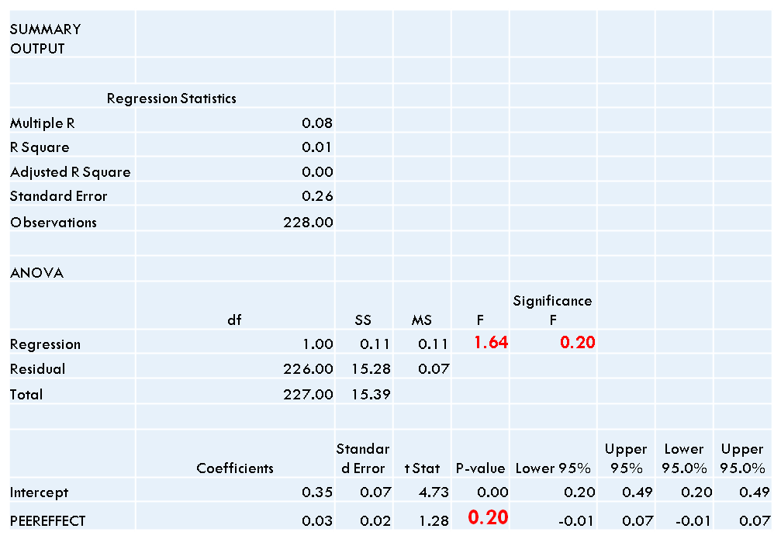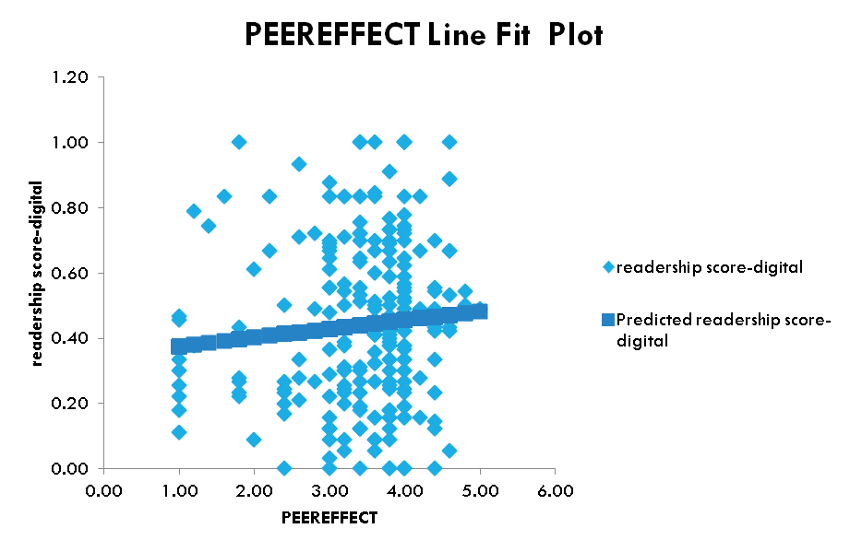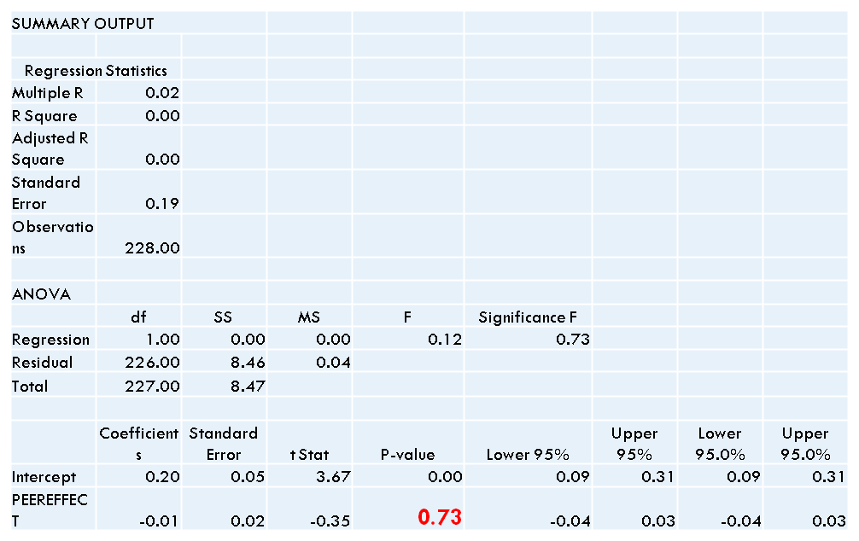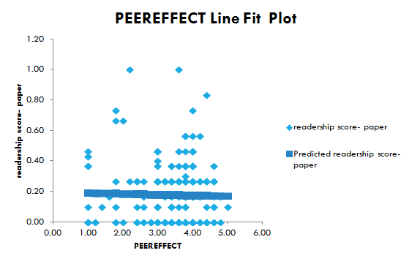

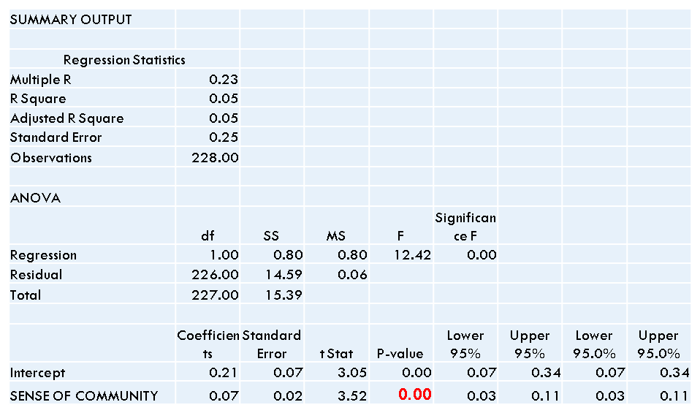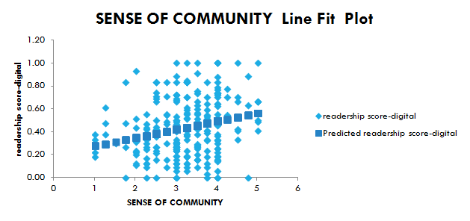

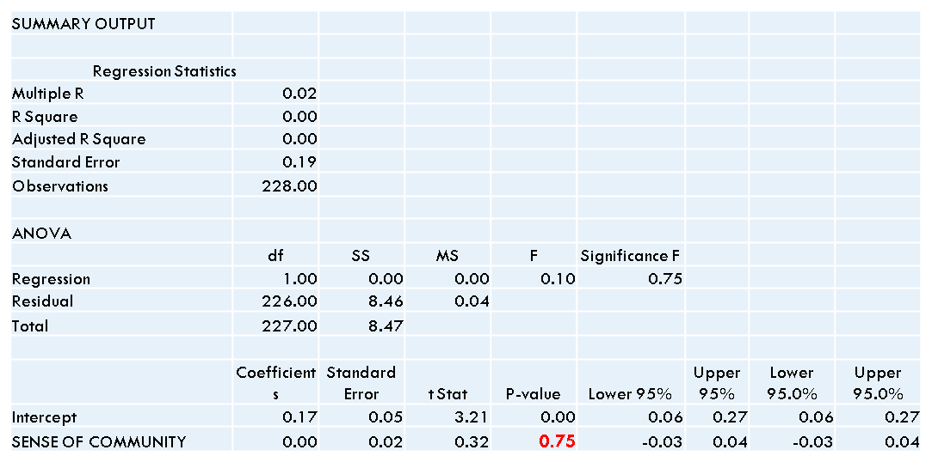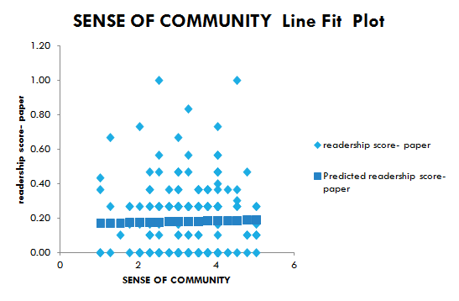

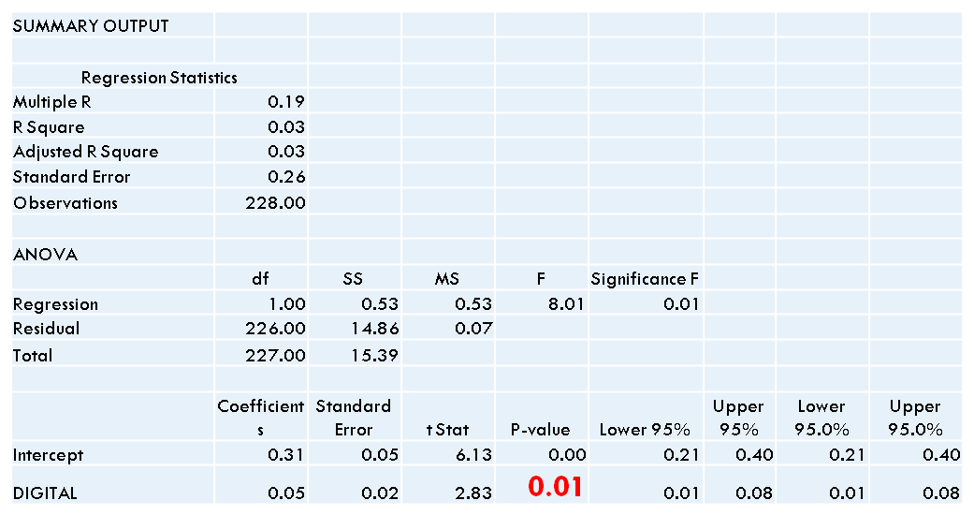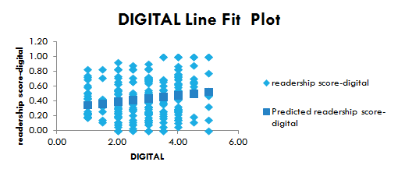

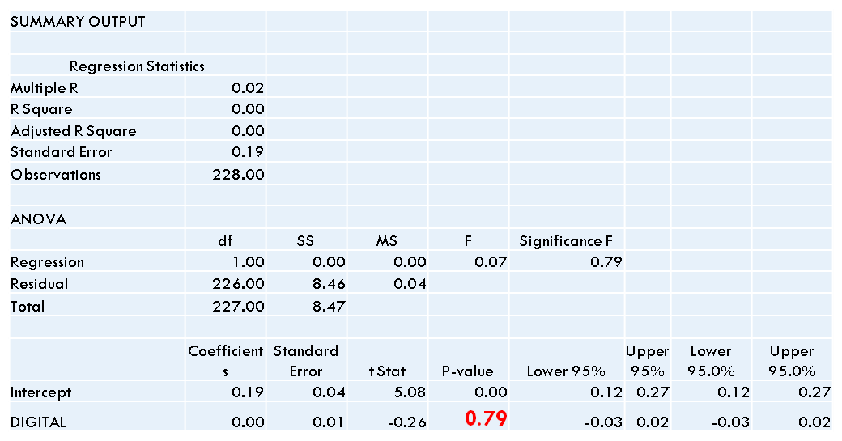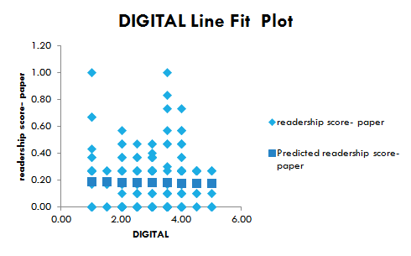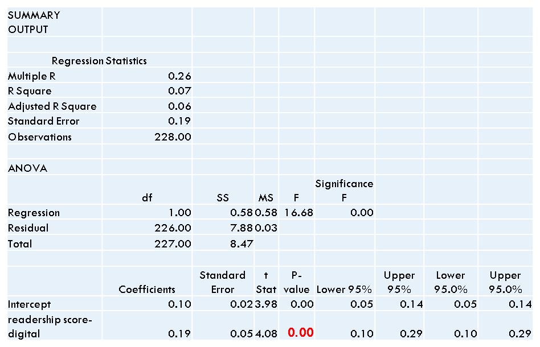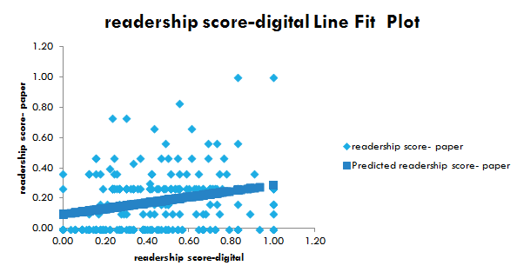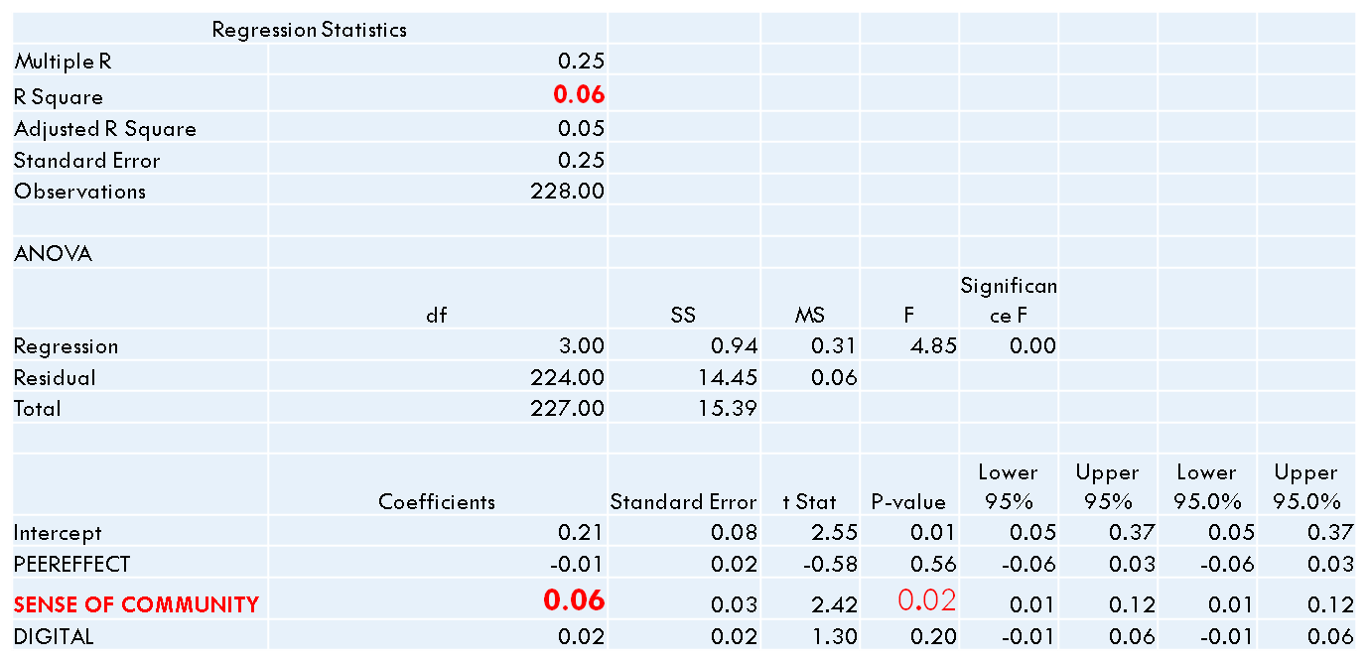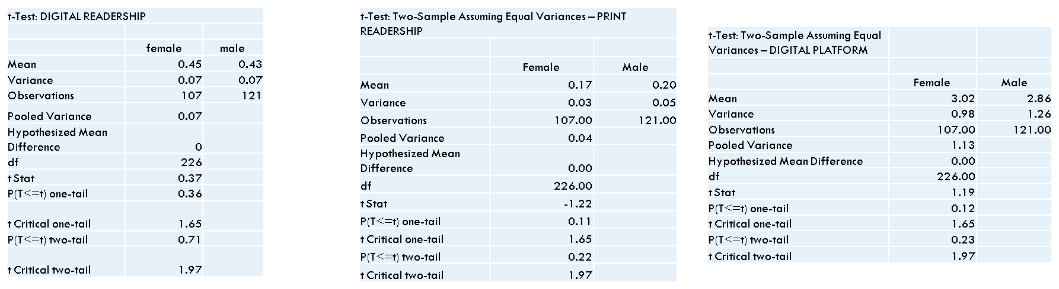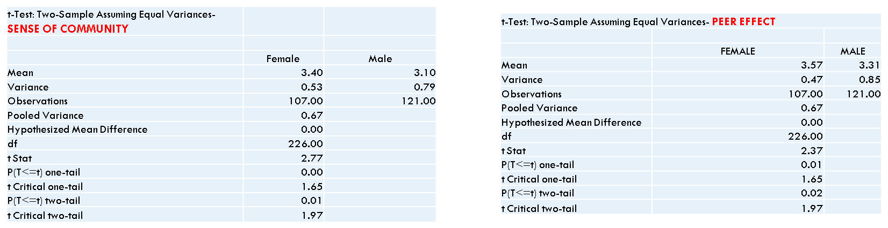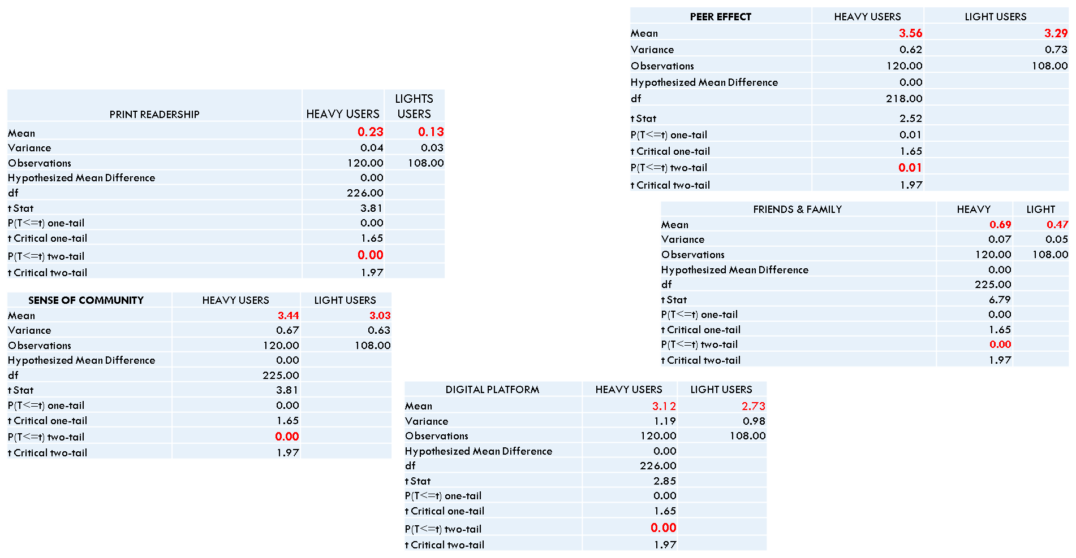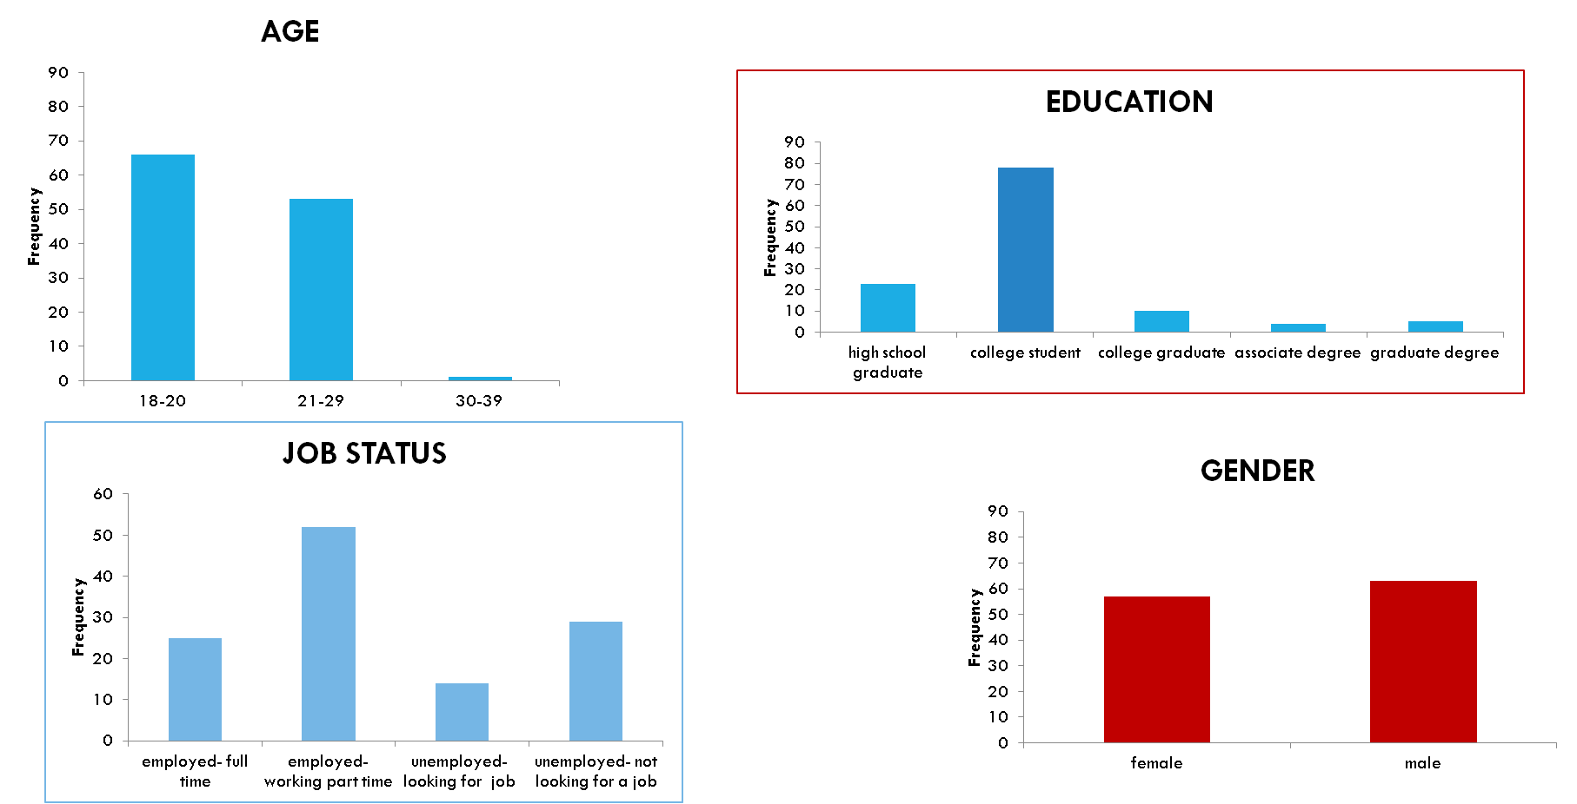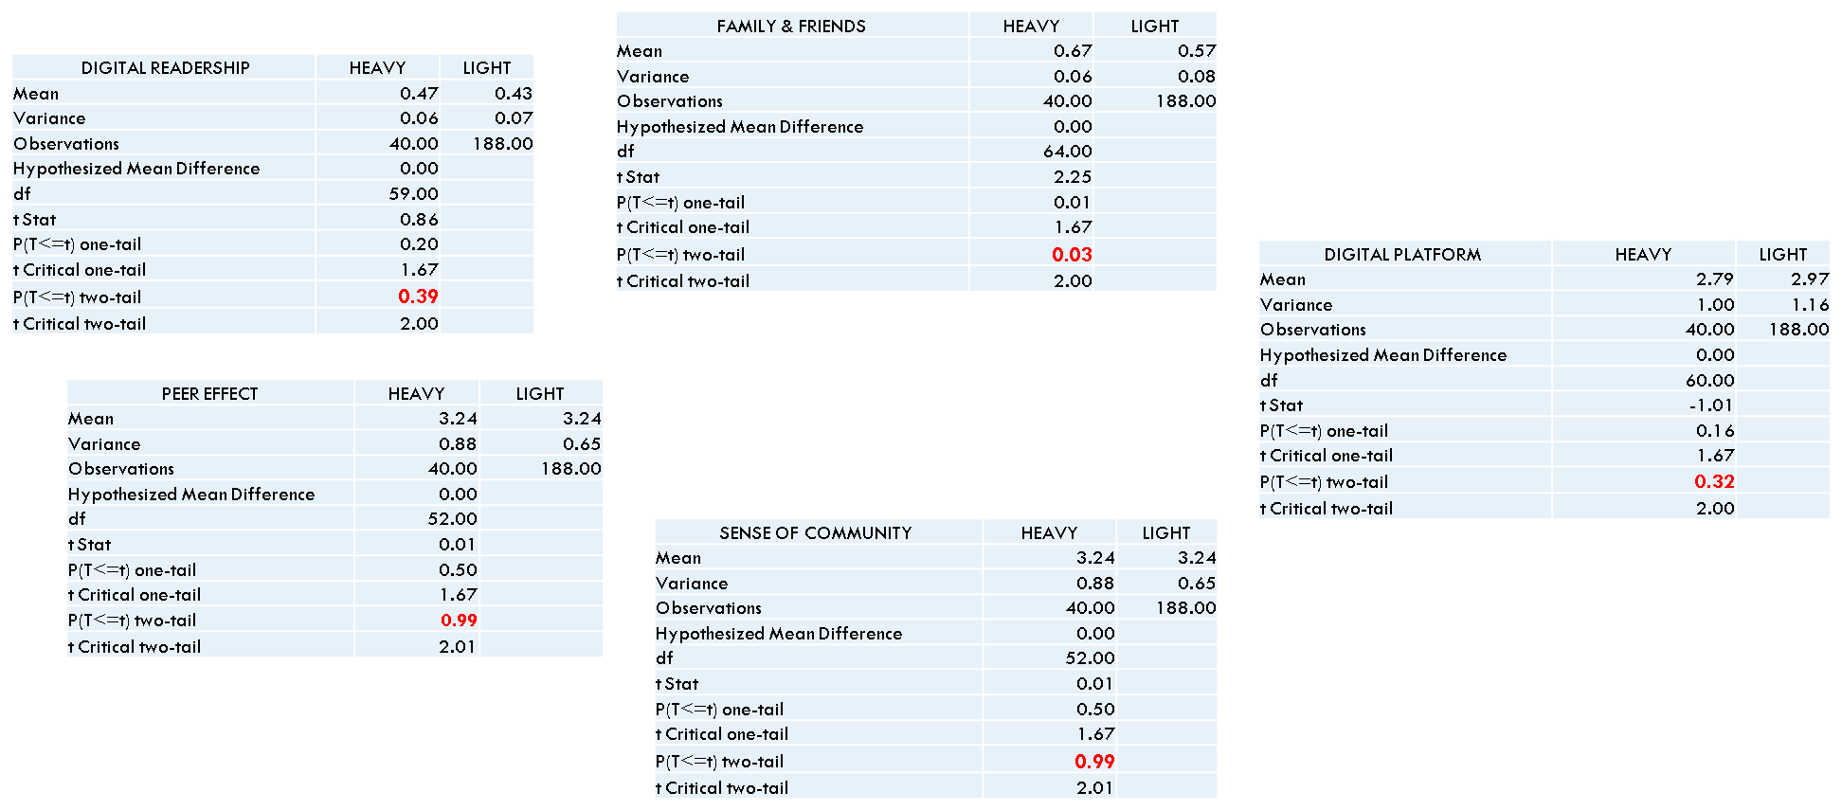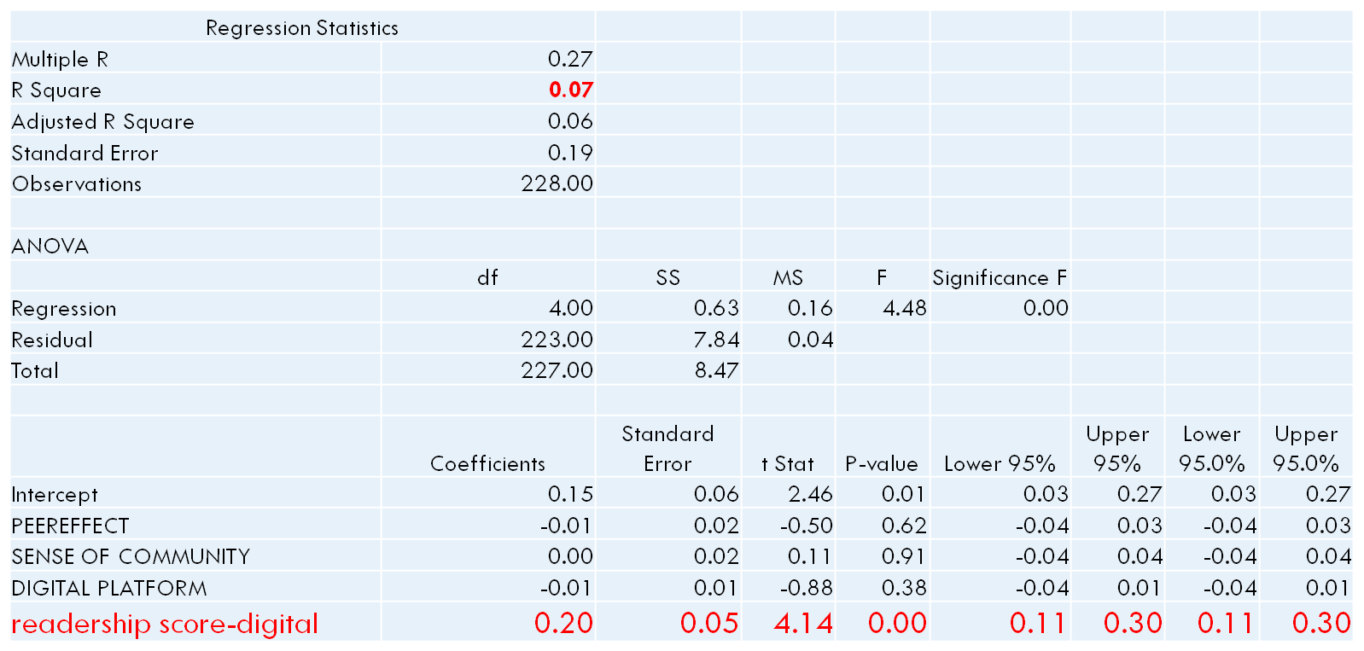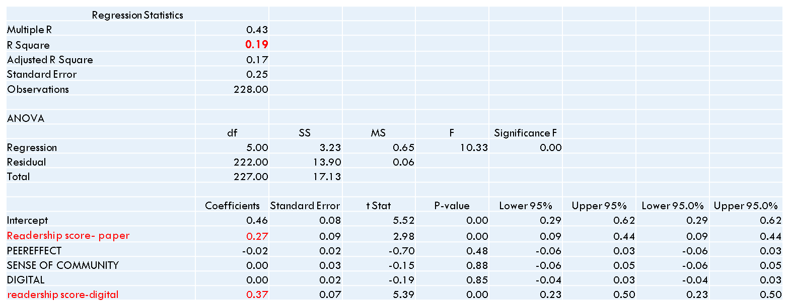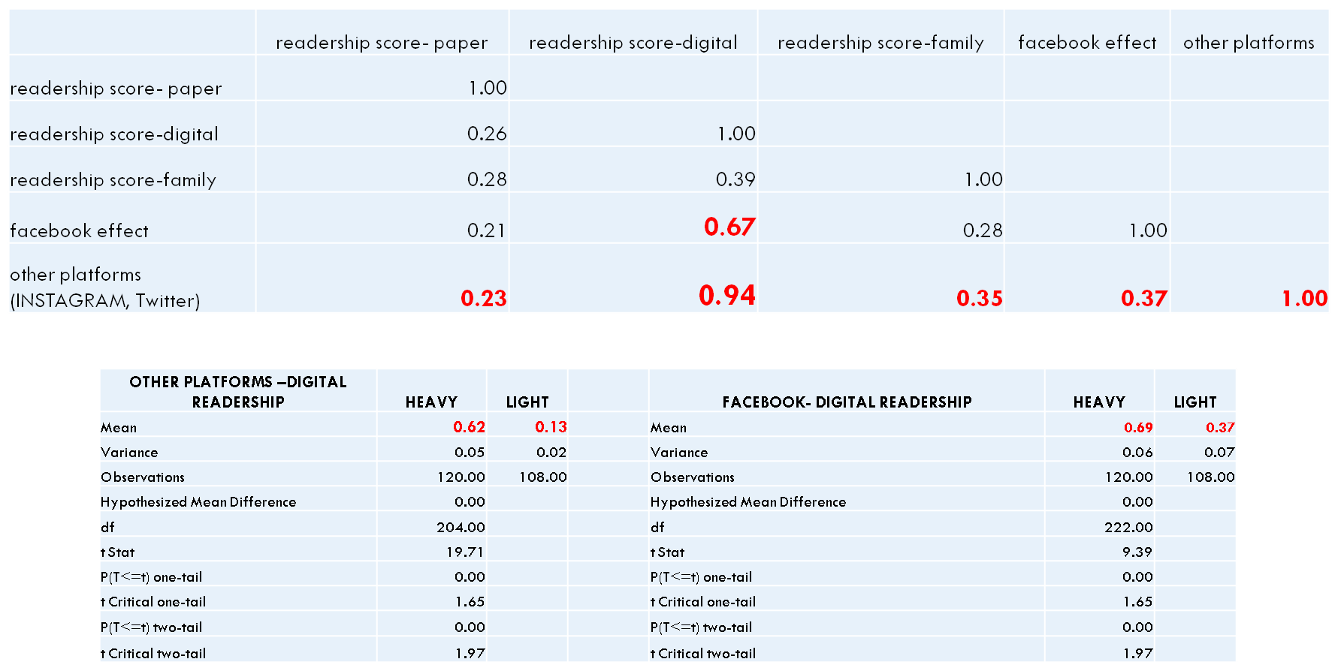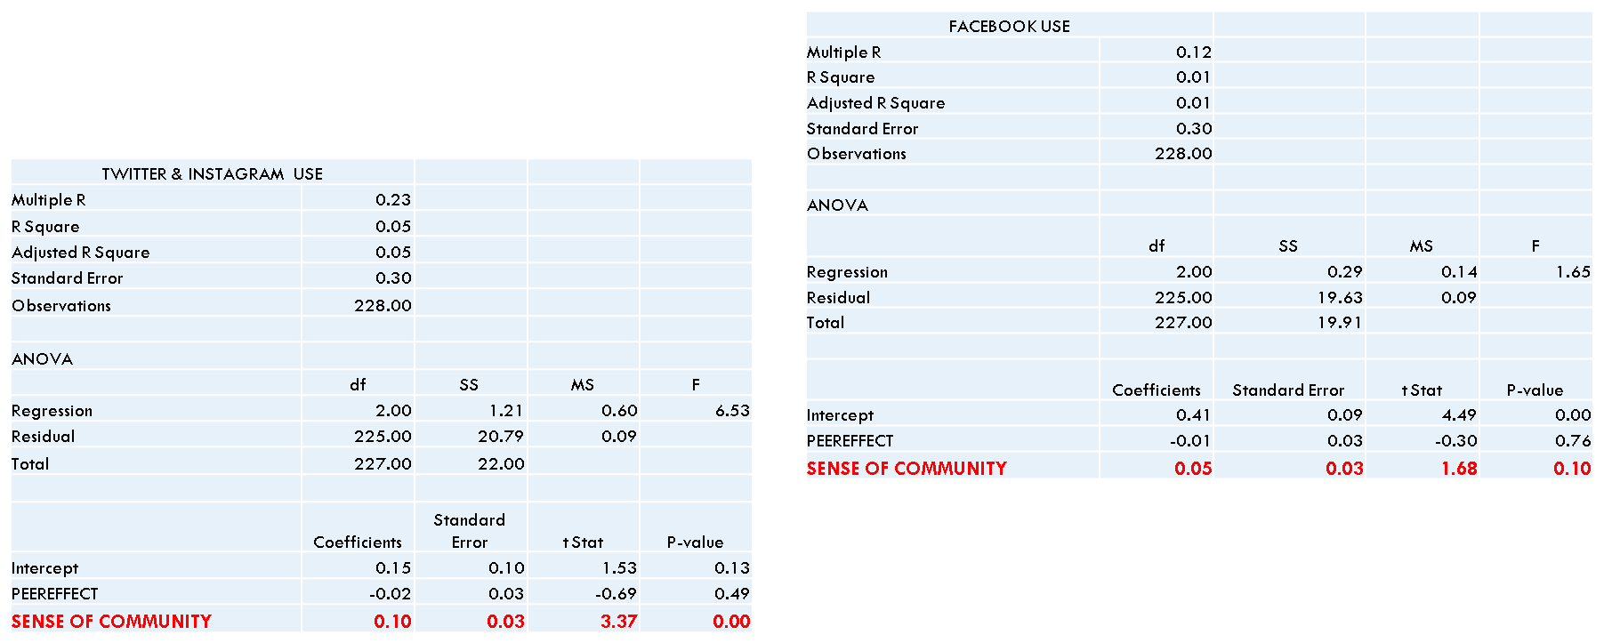

Focus Group Questions

(1) What does being social mean to you? Or, in other words, how do you define being social?

(2) Can you give us some highlights about your social activities? [make them list the social things they do]

(3) Where do you get the information on social events? How do you hear/know what is going on in Erie?

(4) Which information sources do you find more reliable when it comes to getting your social events?

(5) What are the important factors that make you attend social events?

(6) Which format do you prefer (paper vs. mobile)? Why?

(7) What is your opinion on social media being a source for social events? Please elaborate your thoughts.

MKTG 342 Erie- Times News Showc@ase Project The power of “Like”: A Message from Millennial to Erie-Times News Qualitative Research Findings, Hypothesis, and Survey Questions

H1: (a) Publishing on social media platforms increases readership (b) Publishing on Facebook increases readership more than publishing on any other social platform

H2: Readership increases when the content is created by those they perceive to be their peers

H3: (a) Readership increases if they have the knowledge of their friends and peers read them (b) Readership increases if the news engages them

H4: Readership increases if sense of community is communicated through content

H5: Readership increases if the readers feel sense of control H6: Print readership increases with an active online readership Survey questions:

Q1. Where do you get your news about social events to attend? (a) Newspapers (b) Facebook (c) Twitter (d) Instagram (e) Friends (f) Flyers (g) Other (please indicate)

Q2. How much time do you spend on an average weekday (Monday-Friday) looking into the sources below to find out social events to attend? (a) Newspapers (1- 30 min) (31-60 min) (more than an hour) (b) Facebook (1- 30 min) (31-60 min) (more than an hour) (1- 30 min) (31-60 min) (more than an hour) (c) Twitter(1- 30 min) (31-60 min) (more than an hour) (d) Instagram (1- 30 min) (31-60 min) (more than an hour) (e) Friends (1- 30 min) (31-60 min) (more than an hour) (f) Flyers (1- 30 min) (31-60 min) (more than an hour) (g) Other (please indicate) (1- 30 min) (31-60 min) (more than an hour)

Q3. How much time do you spend on an average weekend (Saturday-Sunday) looking into the sources below to find out social events to attend? (a) Newspapers (1- 30 min) (31-60 min) (more than an hour) (b) Facebook (1- 30 min) (31-60 min) (more than an hour) (1- 30 min) (31-60 min) (more than an hour) (c) Twitter(1- 30 min) (31-60 min) (more than an hour) (d) Instagram (1- 30 min) (31-60 min) (more than an hour) (e) Friends (1- 30 min) (31-60 min) (more than an hour) (f) Flyers (1- 30 min) (31-60 min) (more than an hour) (g) Other (please indicate) (1- 30 min) (31-60 min) (more than an hour)

Q4. On average, how frequently do you look into the platforms below to find out social events to attend? (a) Newspapers (more than once everyday) (once everyday) (2-3 times a week) (once a week) (few times a month) (b) Facebook (more than once everyday) (once everyday) (2-3 times a week) (once a week) (few times a month) (c) Twitter (more than once everyday) (once everyday) (2-3 times a week) (once a week) (few times a month) (d) Instagram (more than once everyday) (once everyday) (2-3 times a week) (once a week) (few times a month) (e) Friends (more than once everyday) (once everyday) (2-3 times a week) (once a week) (few times a month) (f) Flyers (more than once everyday) (once everyday) (2-3 times a week) (once a week) (few times a month) (g) Other (please indicate) (more than once everyday) (once everyday) (2-3 times a week) (once a week) (few times a month)

Q5 Having the chance of interacting with people on the social networking sites makes me interested in reading the social event news on those sites

Q6. Seeing my friends interacting with news (e.g. liking, commenting) increases my intention to read the social event news

Q7. Seeing my friends going to an event that is posted on a social media account increases my intention to attend to the event

Q8. Knowing my friends going to an event increases my intention to attend to the event

Q9. Seeing posts made my friends and peers make me interested in reading the posts

Q10. In general, interacting with friends on the social media sites about social events to attend makes me feel like part of a larger community

Q11. In general, interacting with people on the social media sites about social events to attend makes me feel connected to a community

Q12. Interacting with people on the social media sites about social events to attend reminds me that everyone is connected

Q13. Interacting with people on the social media sites about social events to attend increases my sense of belonging

Q14. Which of these, if any, are the main reasons that you use Facebook? (a) see what friends are talking about (b) find things that entertain them (c) look for interesting articles or links posted (d) share content (e) see what is trending (f) get more information on something heard on news (g) other (please indicate)

Q15. Which of these, if any, are the main reasons that you use Twitter? (a) see what friends are talking about (b) find things that entertain them (c) look for interesting articles or links posted (d) share content (e) see what is trending (f) get more information on something heard on news (g) other (please indicate)

Q16. My intention to read a newspaper to learn about social events to attend increases if that newspaper has an active social media site Q16. My intention to read a newspaper to learn about social events to attend increases if that newspaper has an active social media site that I can access through my phone

Q17. My intention to read to learn about social events to attend increases if it is not a paid advertised event

Q18. (a) I like getting my energy from active involvement in events and having a lot of different activities (b) I'm excited when I'm around people and I like to energize other people. (c) I like moving into action and making things happen. (d) I generally feel at home in the world. (e) I often understand a problem better when I can talk out loud about it and hear what others have to say.

Q19. (a) I like getting my energy from dealing with the ideas, pictures, memories, and reactions that are inside my head, in my inner world. (b) I often prefer doing things alone or with one or two people I feel comfortable with. (c) I take time to reflect so that I have a clear idea of what I'll be doing when I decide to act. (d) Ideas are almost solid things for me. (e) Sometimes I like the idea of something better than the real thing.

Q. 20 Do you read Erie- Times News? – yes – no –never heard of Q.

21 How often do you read Erie Times News? - Weekly - once in a while – none Q.

22 Do you read Showcase (Thursday Social Event insert of the Erie Times News)? – yes – no –never heard of Q.

23 How often do you read Showcase? - Weekly - once in a while – none Q.

24 What are your thoughts on Erie-Times News and Showcase?

Q. 25 Are you from Erie?

Q. 26 Demographics questions (age, occupation, inc